Appendix A

Sorenson Impact Center Data Science Team



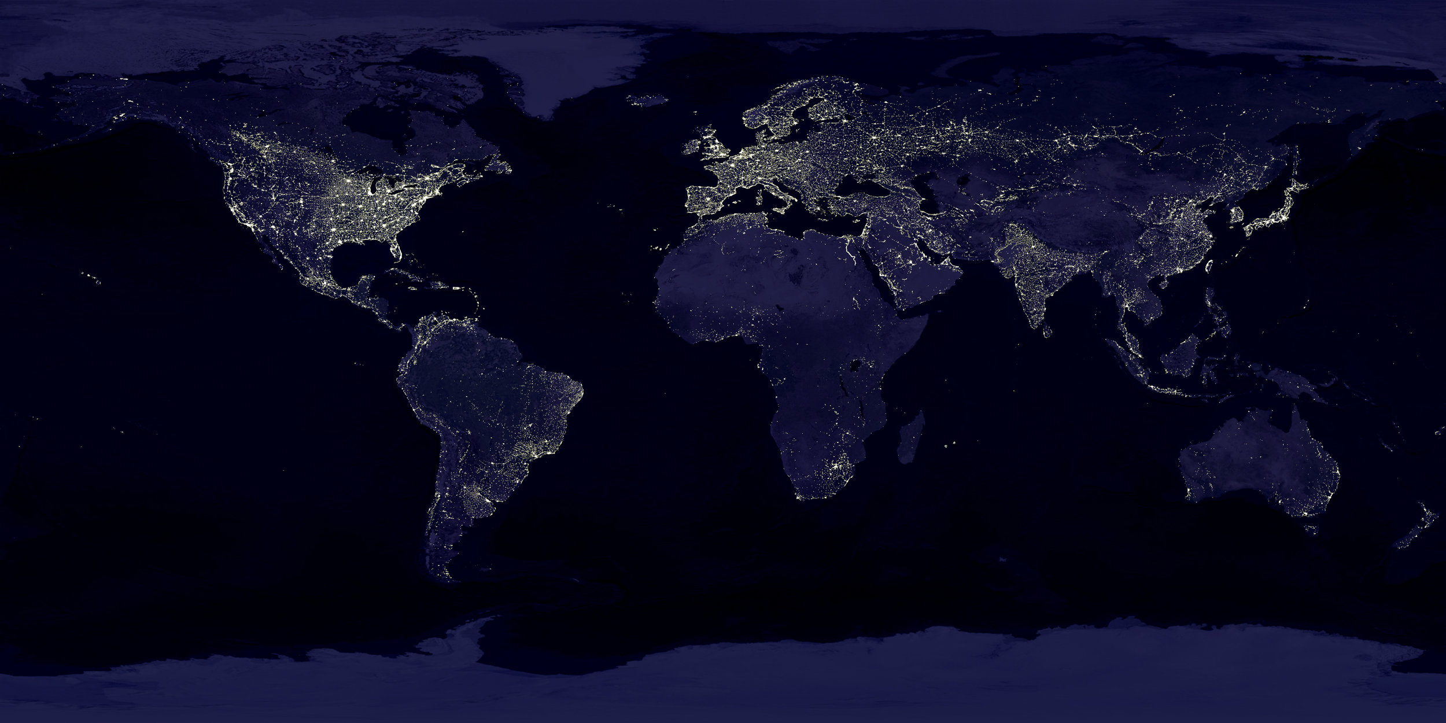

#### A report prepared by the Sorenson Impact Center Data Science Team.

##### Pagebreak

## Introduction

This appendix analyzed a few publicly available data sets related to the well being of residents in the study area.

#### Data Source and Methods

Data sources used here include opendata.gov, the American Community Survey (ACS) Data and the U.S. Census. Both ACS 5-year data and annual data were included for the appropriate visualizations. For annual ACS data, the starting year was set to 2012 because of the limitation of the API pull. ACS annual data is limited to counties with populations greater than 65,000. Consequently, Summit County did not get included in this data set.

For the purposes of clarity of plots and graphs, only Davis, Salt Lake, Summit, Tooele, Utah and Weber Counties were included in this report as these were identified as the primary areas of interest.

#### Results

##### Pagebreak

## Education

The following couple of plots show the distribution of education among the 18-24 year olds and those above 25 years of age. In the 18-25 year old age group, Tooele county has the highest percentage of people with less than high school education and the lowest percentage of those with a bachelor’s degree or higher. Tooele county and Weber county have the highest percentage of less than high school graduate among those over 25 years of age.

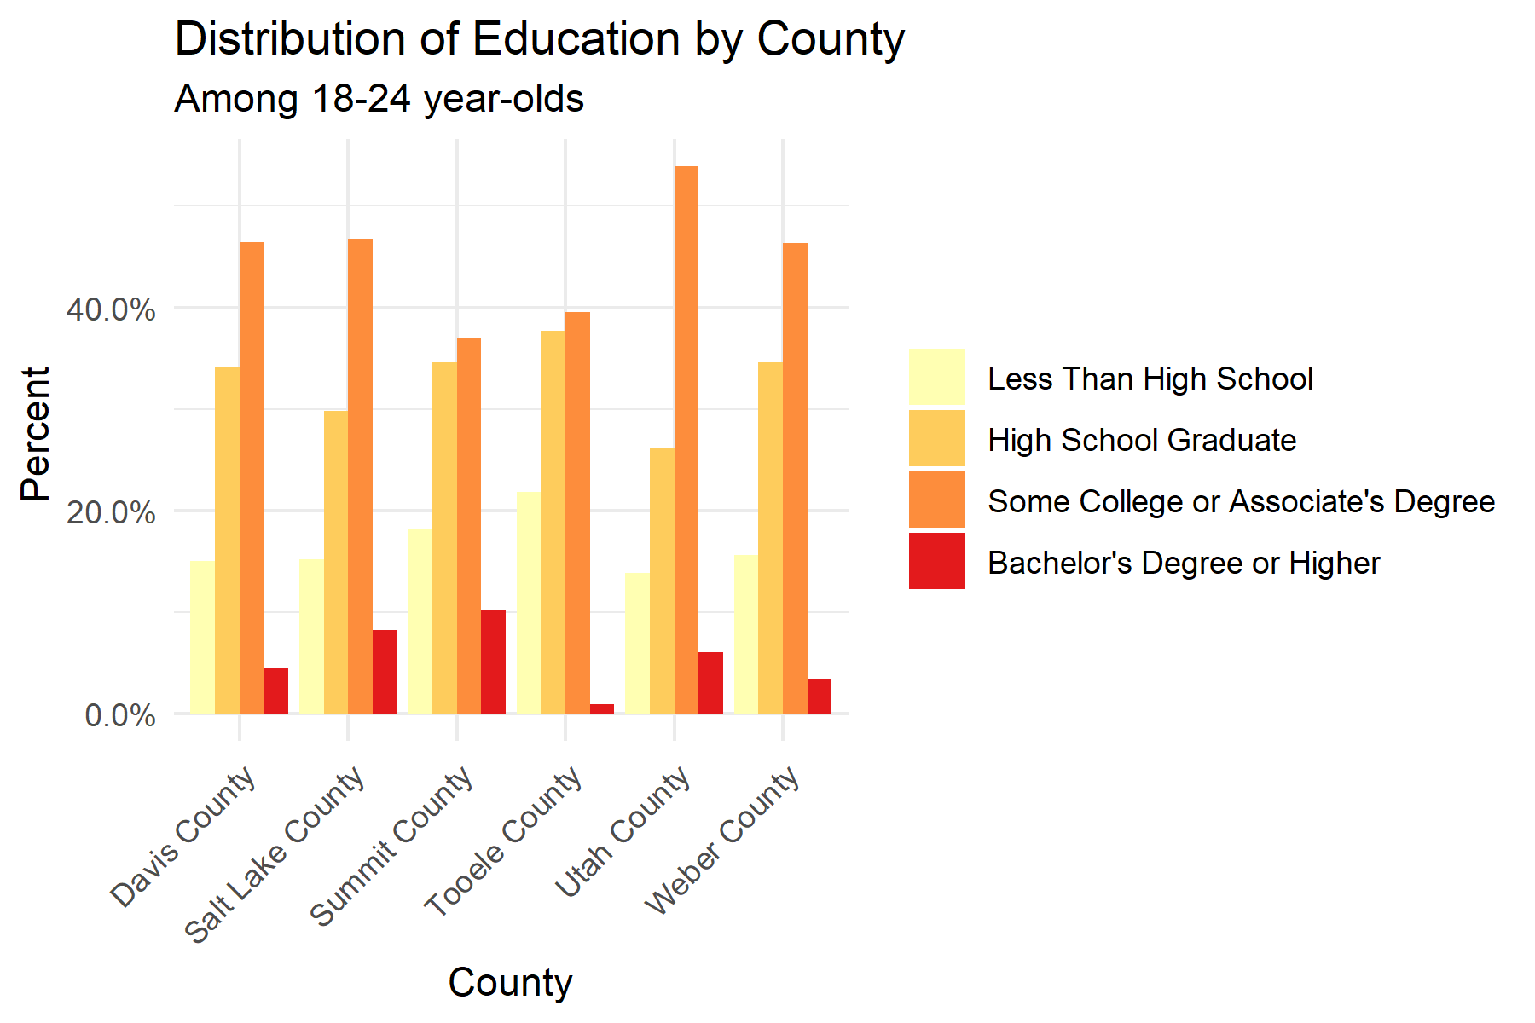

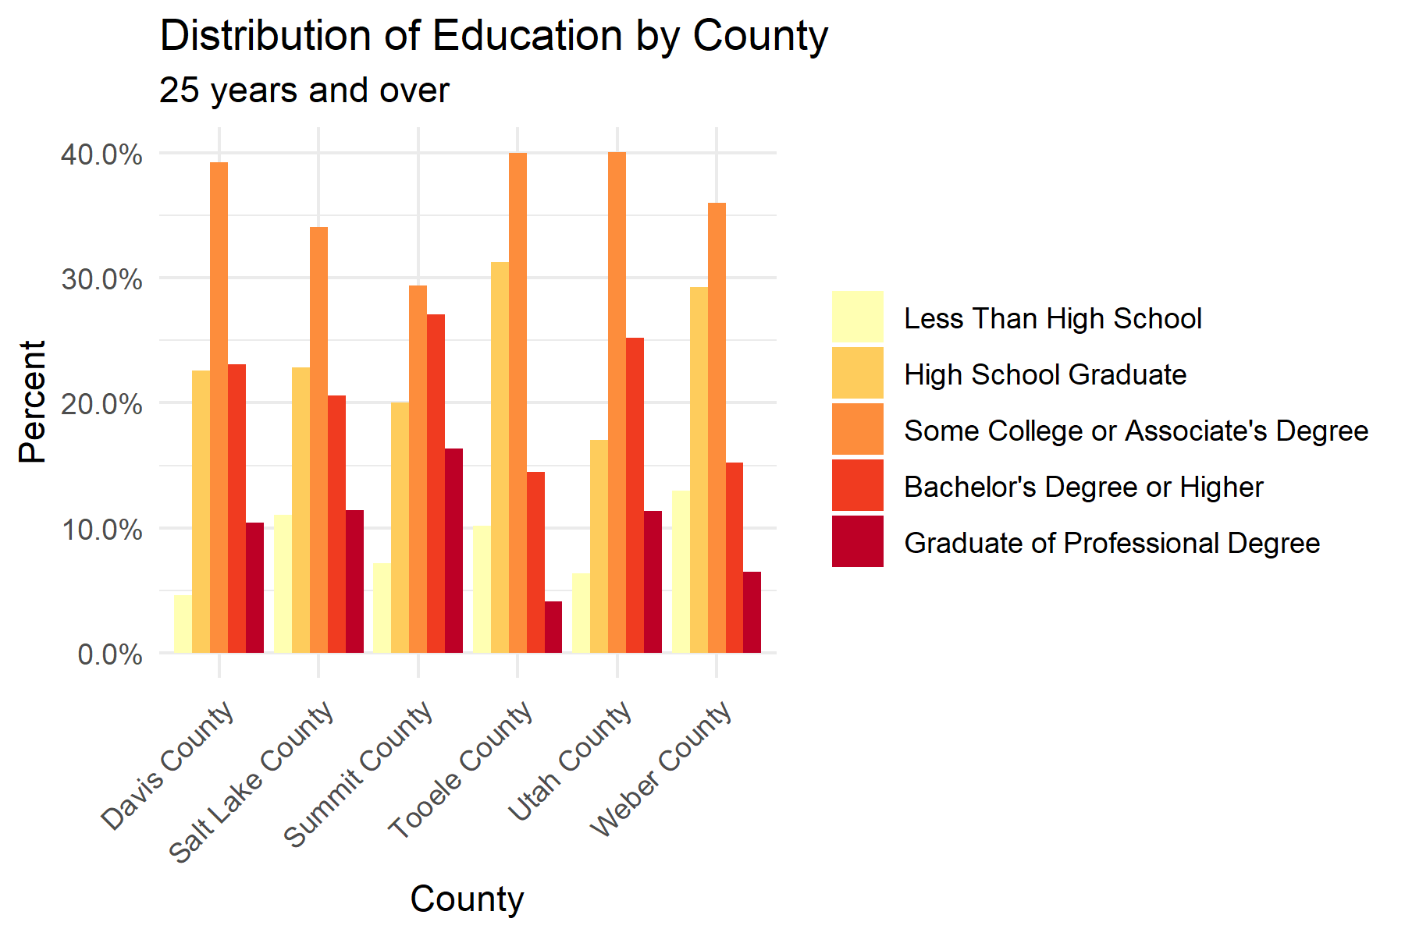

## Unemployment

in 2017, Weber County had the highest unemployment percentage among the civilian labor force.

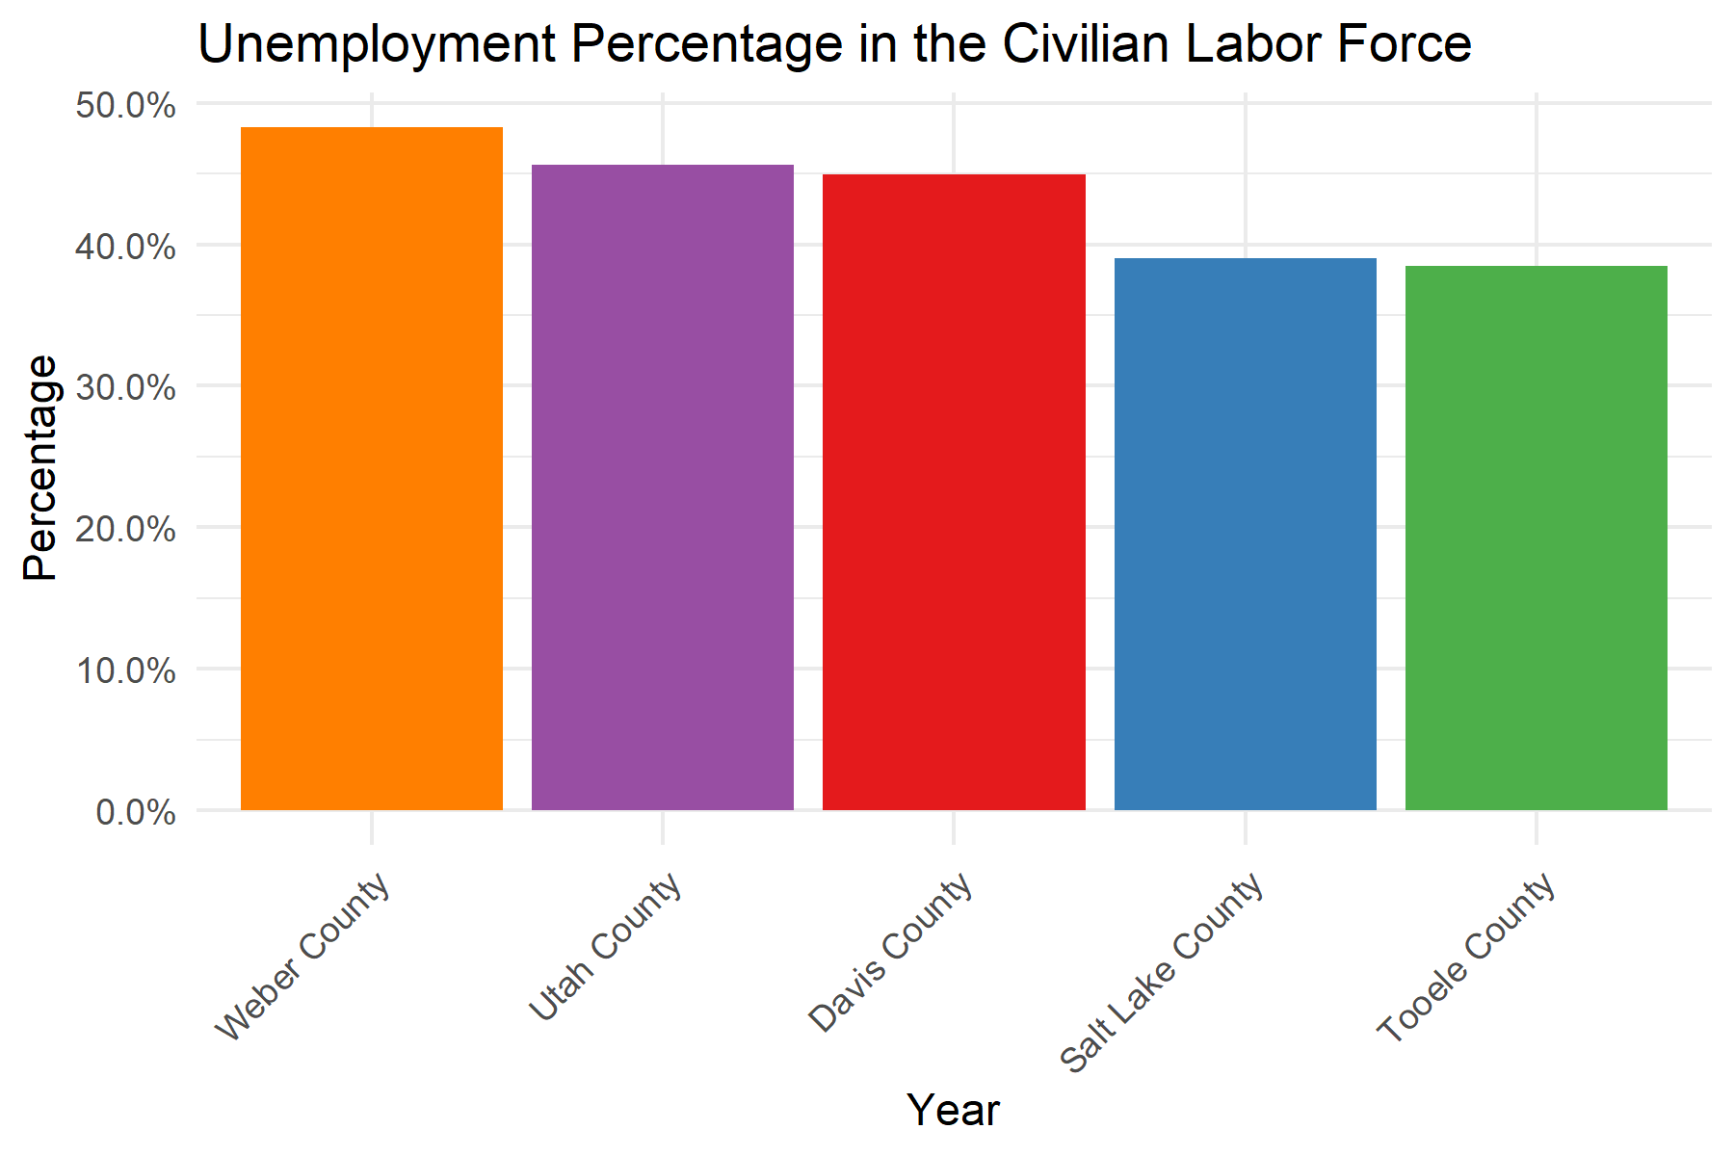

But when looking at the yearly trends, Weber and Salt Lake Counties have seen a decrease in the unemployment rate, while Davis and Utah Counties have seen an increase in unemployment percentage over the last 6 years. Tooele County was excluded from due to lack of annual data.

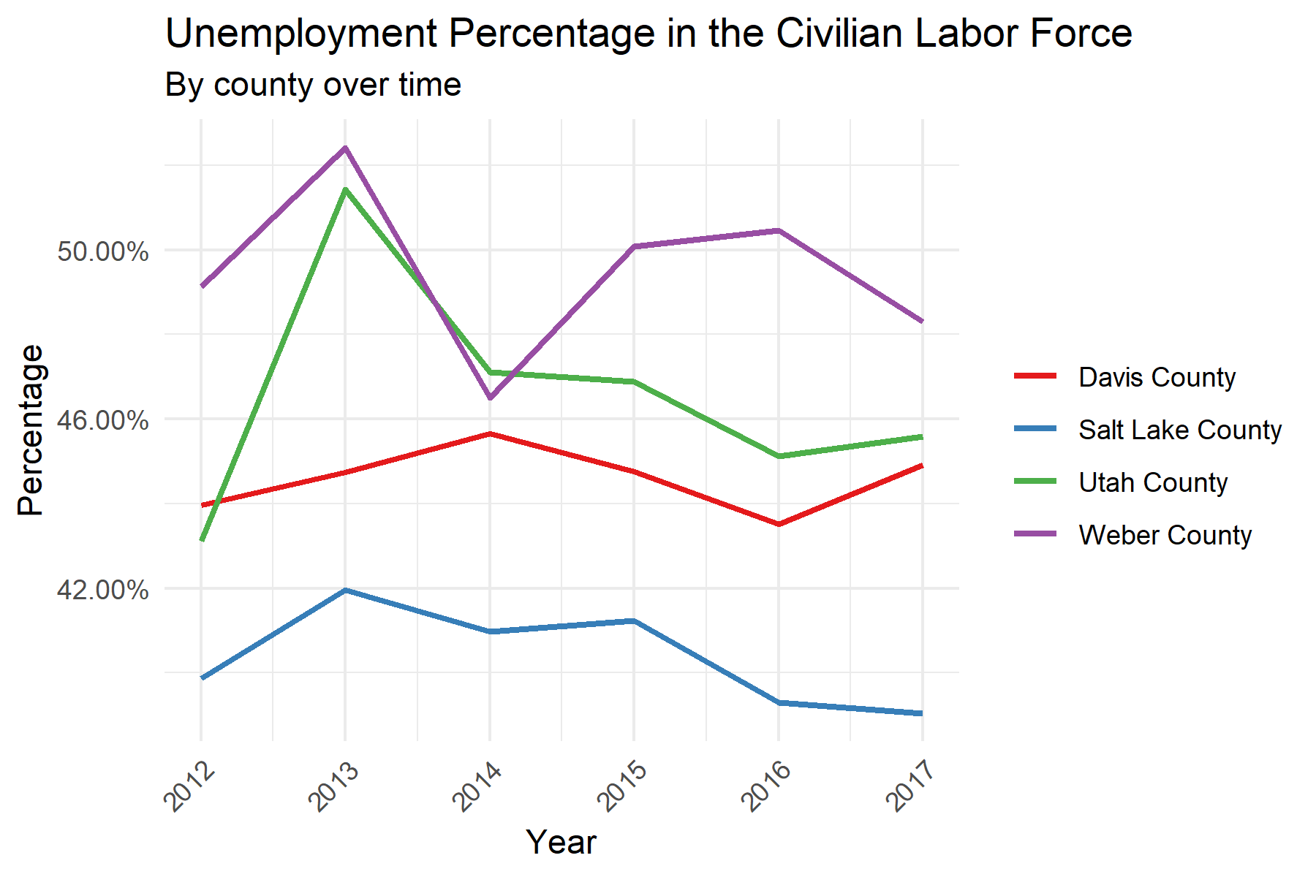

The median household income has increased over time in all the counties of interest with Summit County having the highest median income and Weber County with the lowest median income.

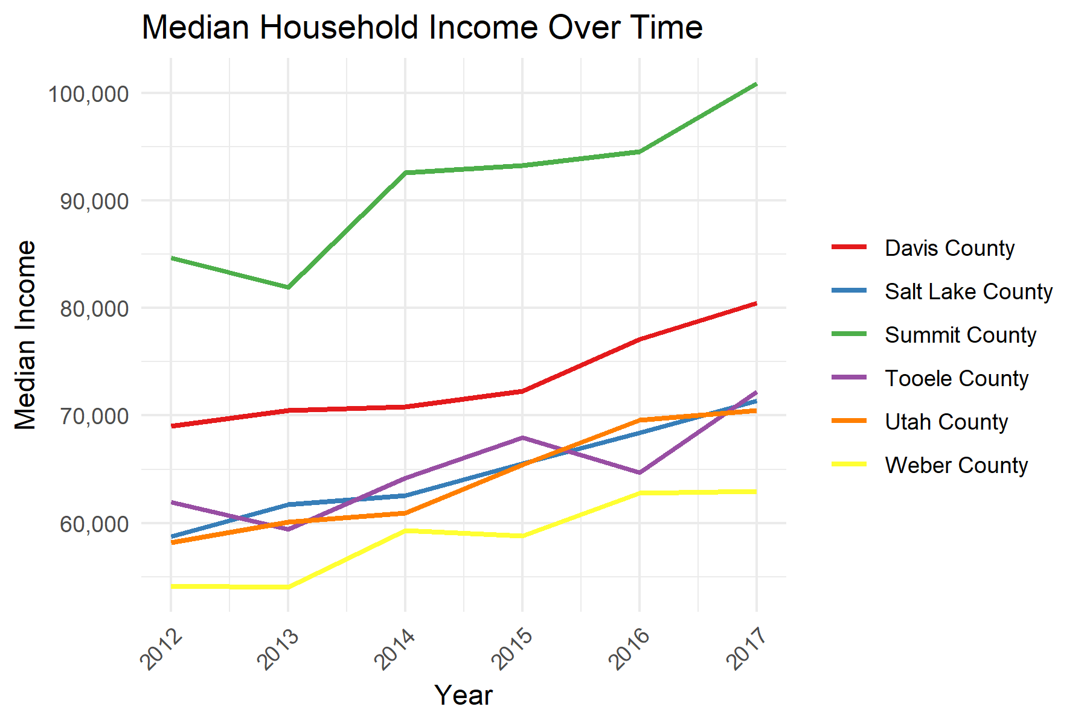

This map shows that Summit County has the highest median household income in Utah and the lowest being Piute County.

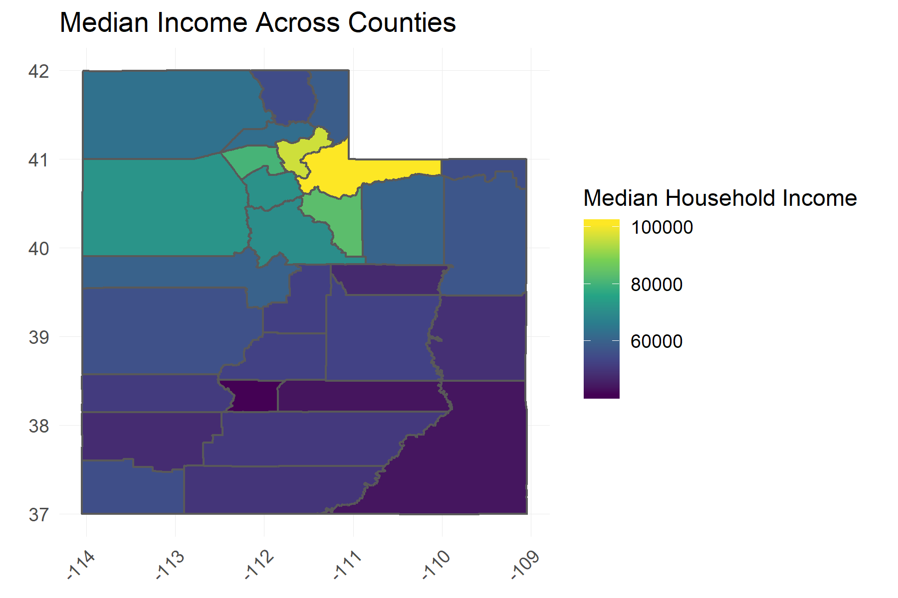

This lot shows that Tooele has the lowest Gini Index.

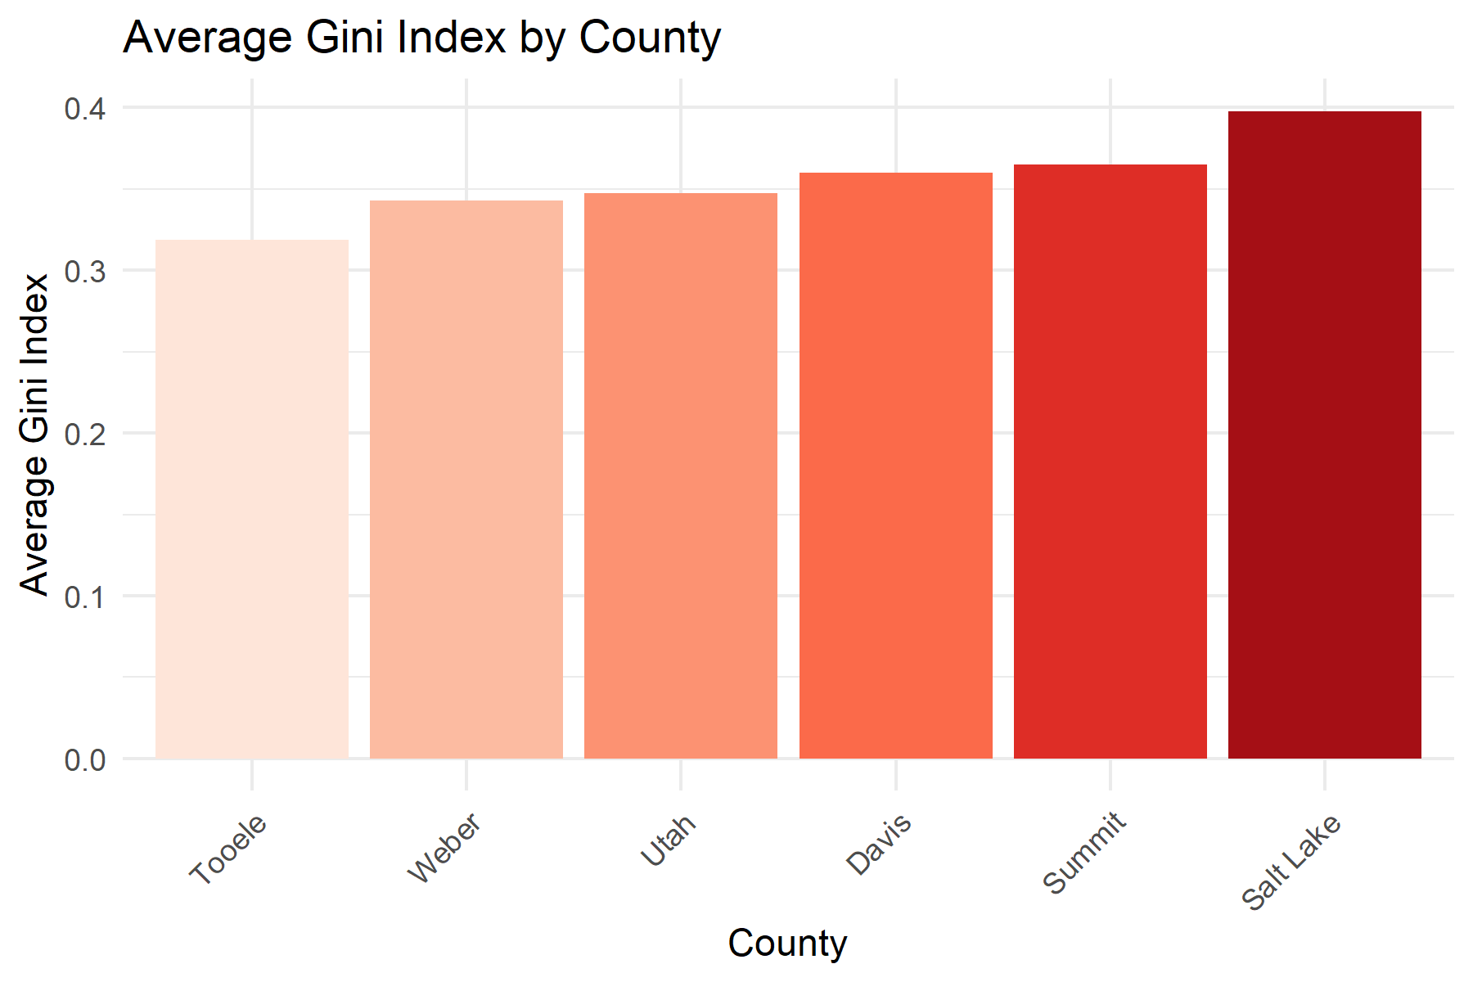

Tooele also has the lowest Gini Index to median Household income ratio, which is indicative of a fairly equal distribution of low income.

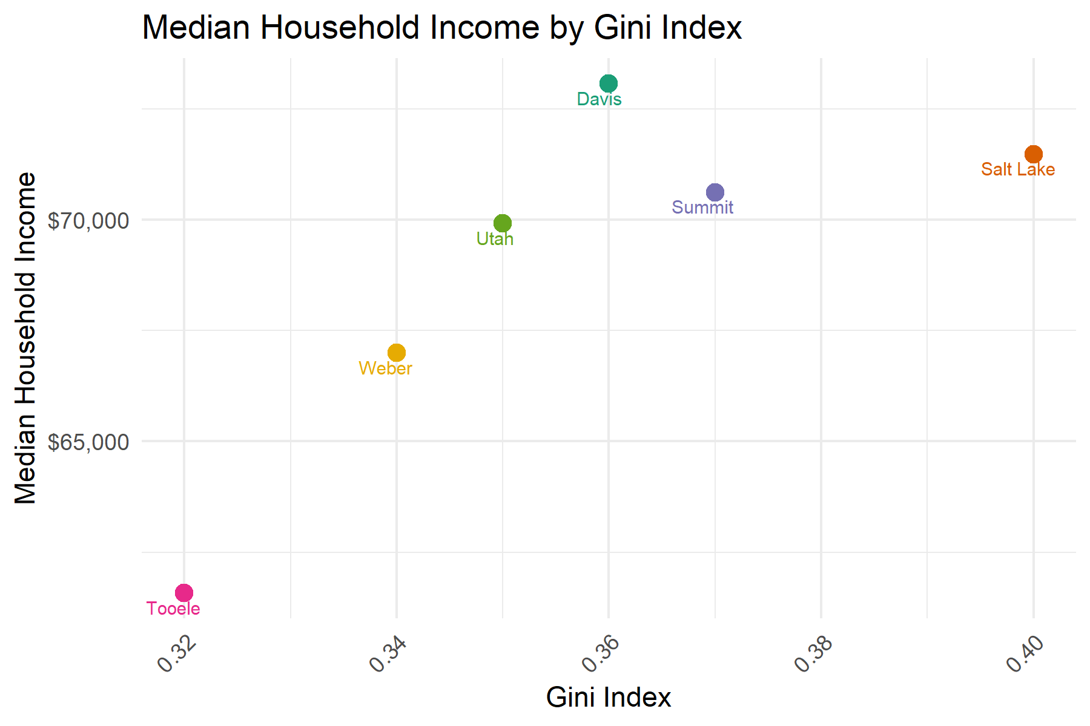

When looking at cities and their Gini Index, Alta has the highest Gini Index and Ophir (in Utah county) has the lowest Gini Index.

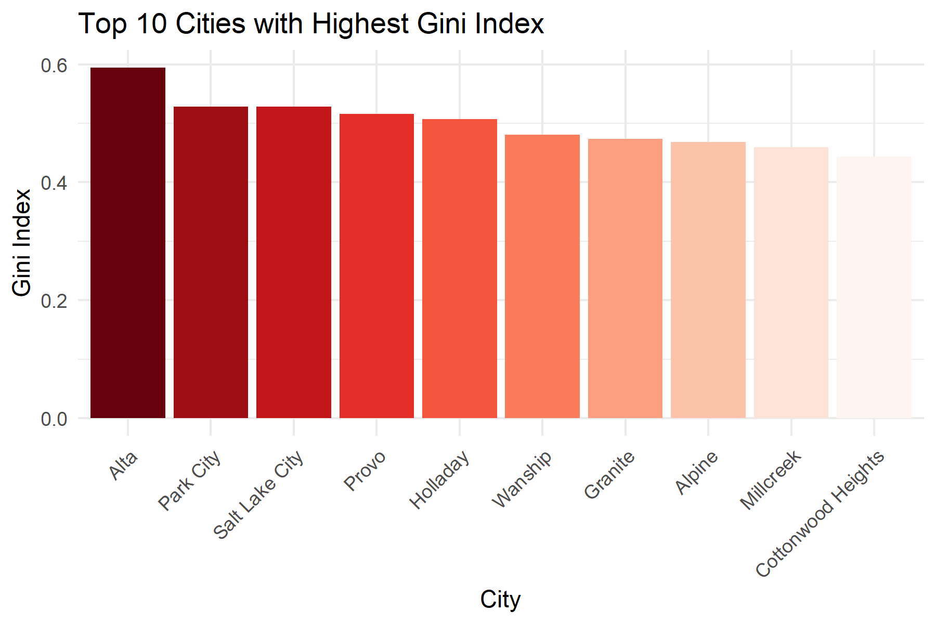

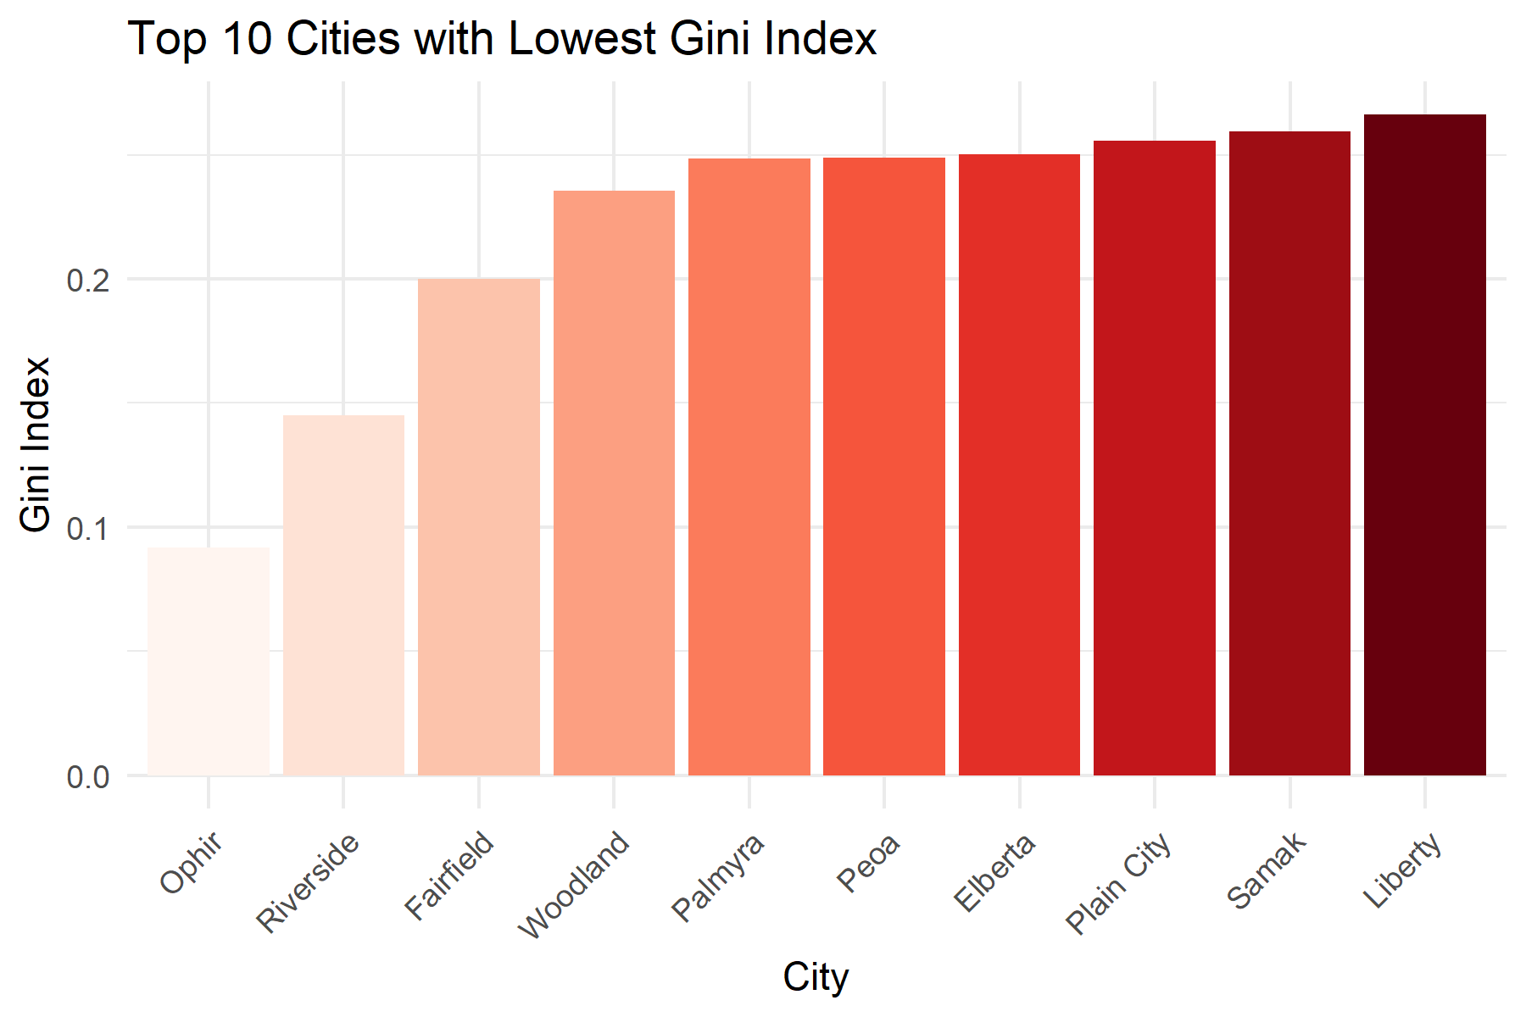

Ophir also has a high median income and a low Gini Index indicating an equal distribution of high income in the community, while cities Riverside has a low Gini Index and a low median income, indicative of a poorer city.

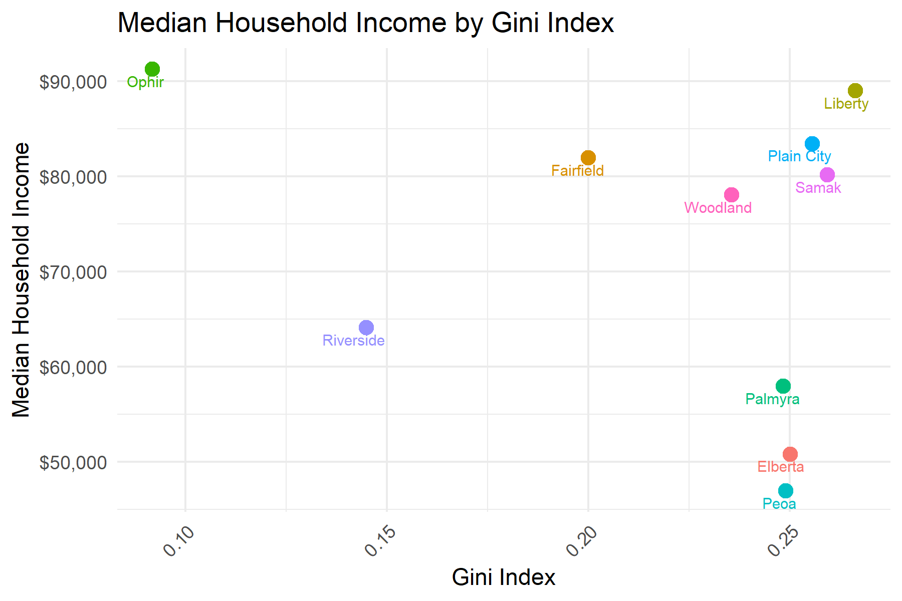

While Salt Lake County does not have the highest poverty rate among the counties of interest, it does have the highest population below poverty level which poses a significant burden on the county.

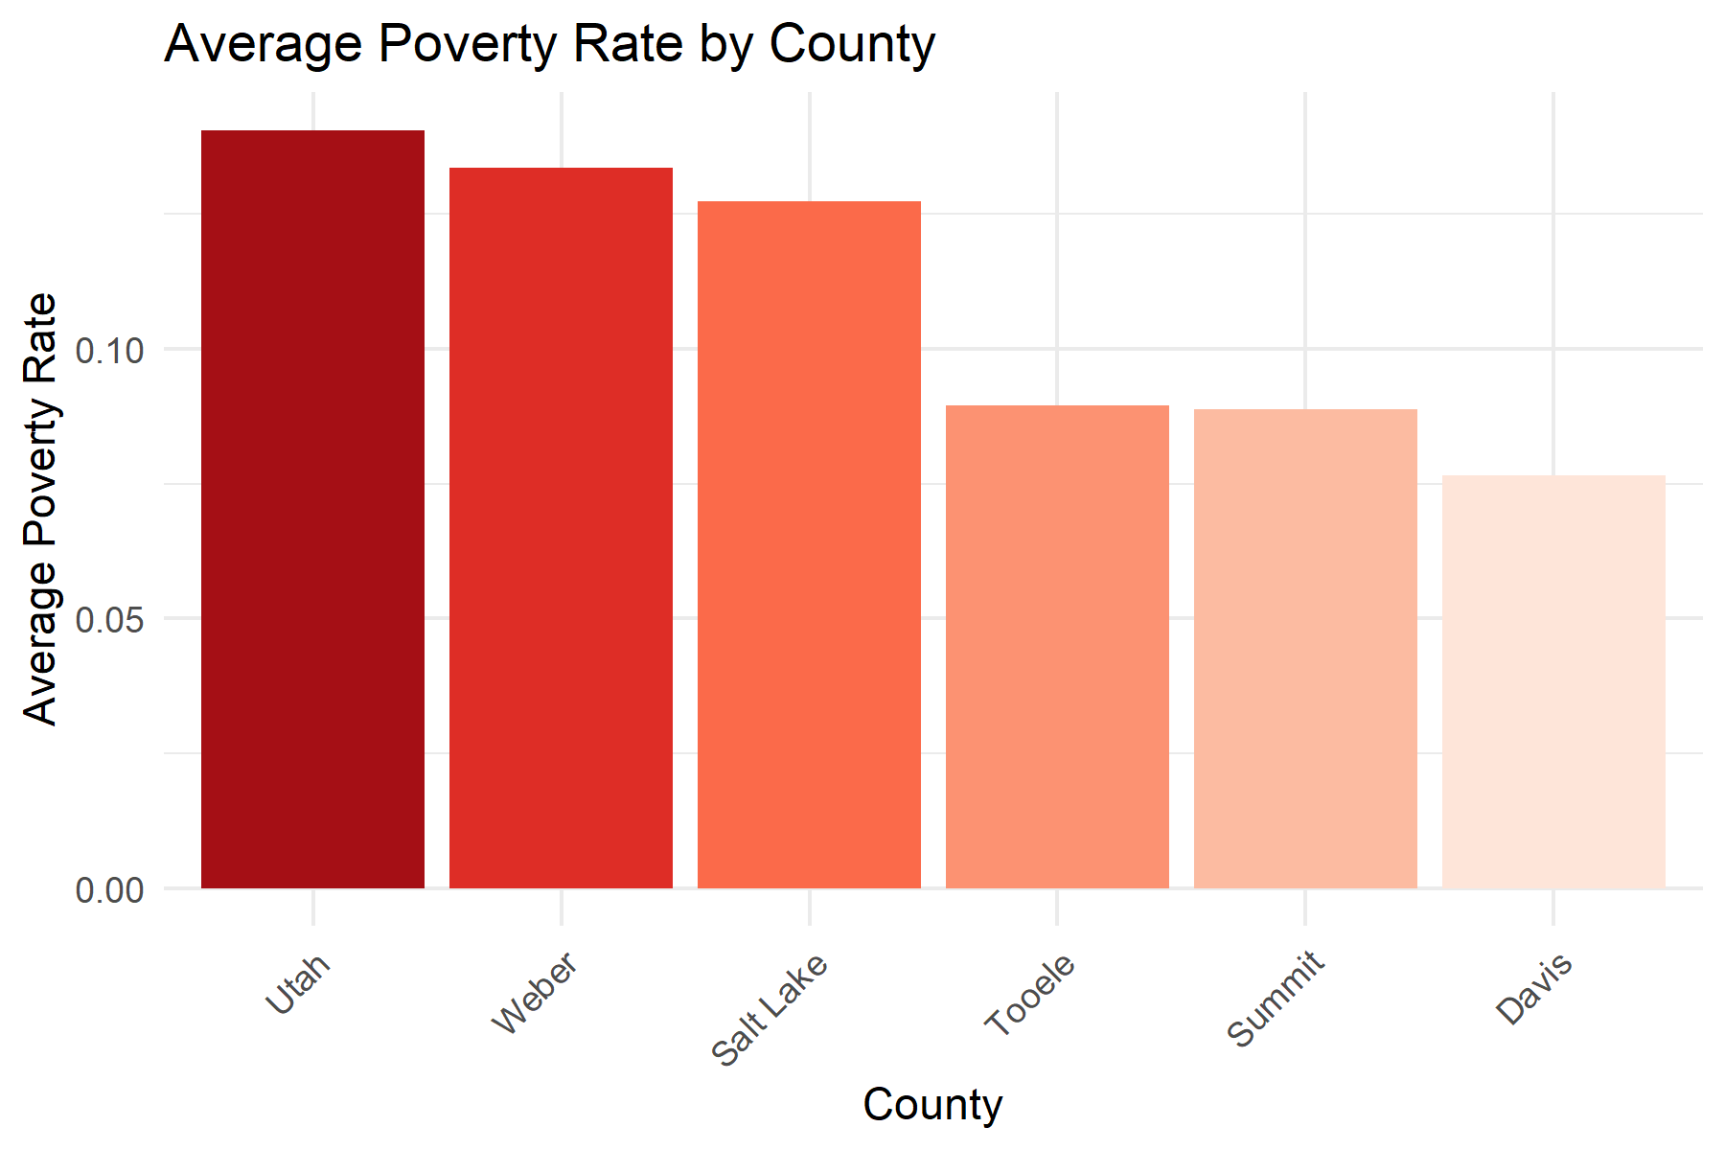

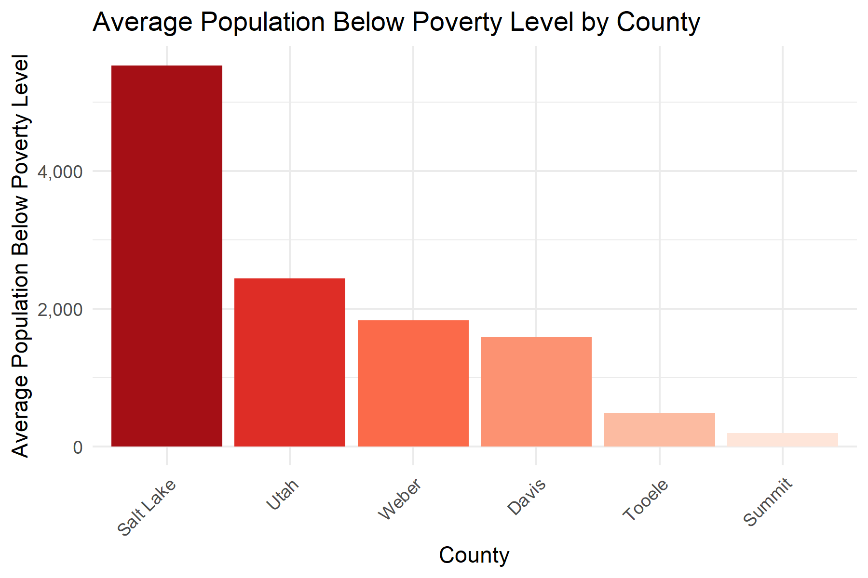

7 out of 10 cities with the highest populations below poverty level belong to Salt Lake County.

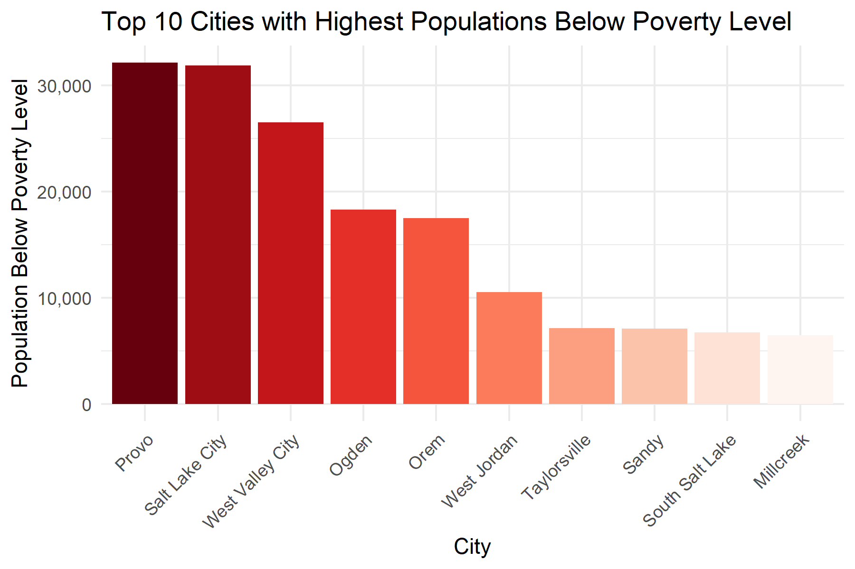

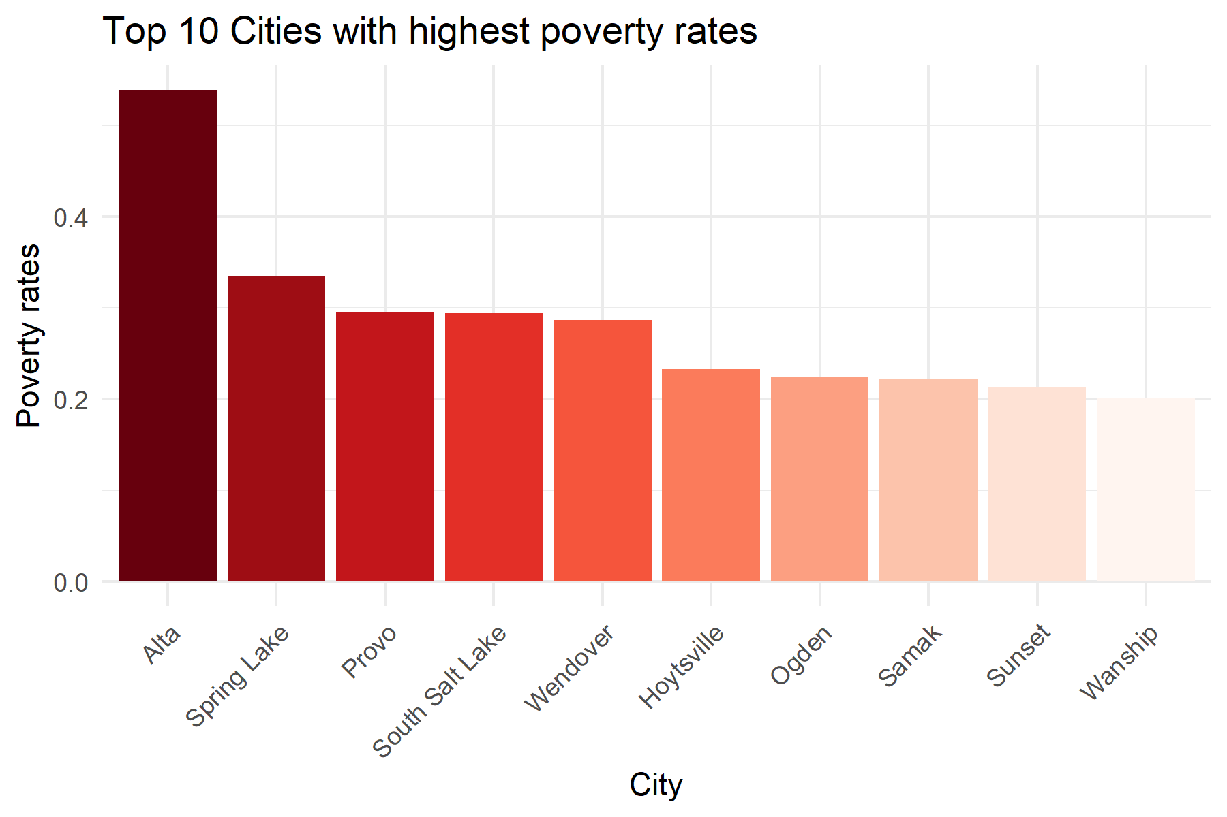

The rates of poverty between men and women are very comparable for the top 10 cities with the highest poverty rates, with the exception of Alta and Samak.

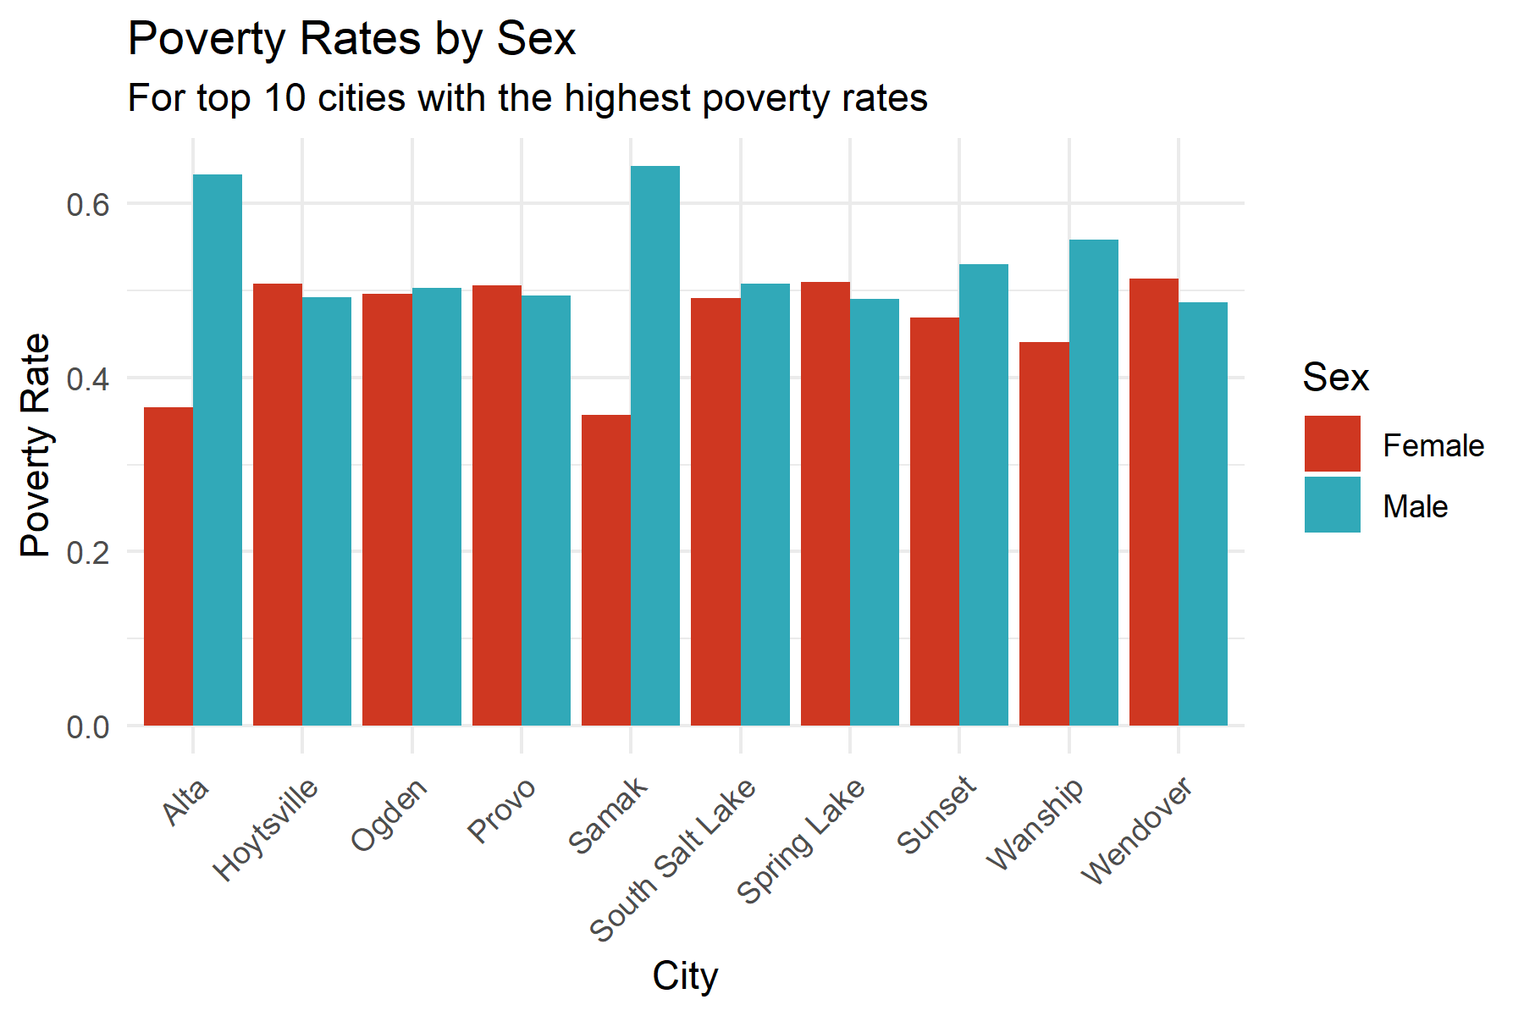

The poverty rates have decreased over time for all counties of interest which is hopeful.

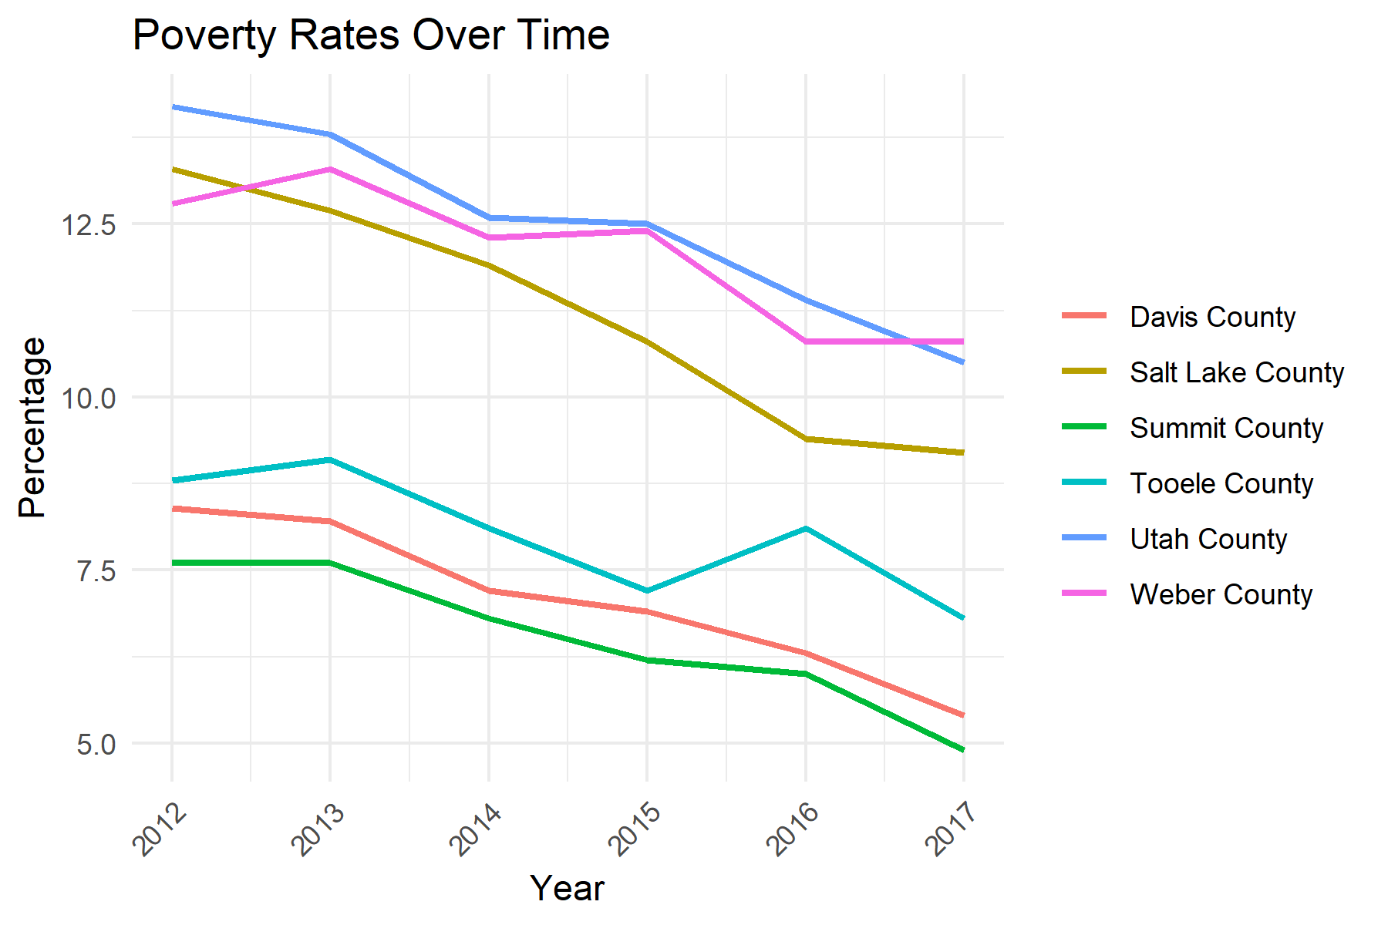

The highest poverty rate in Utah is in San Juan county.

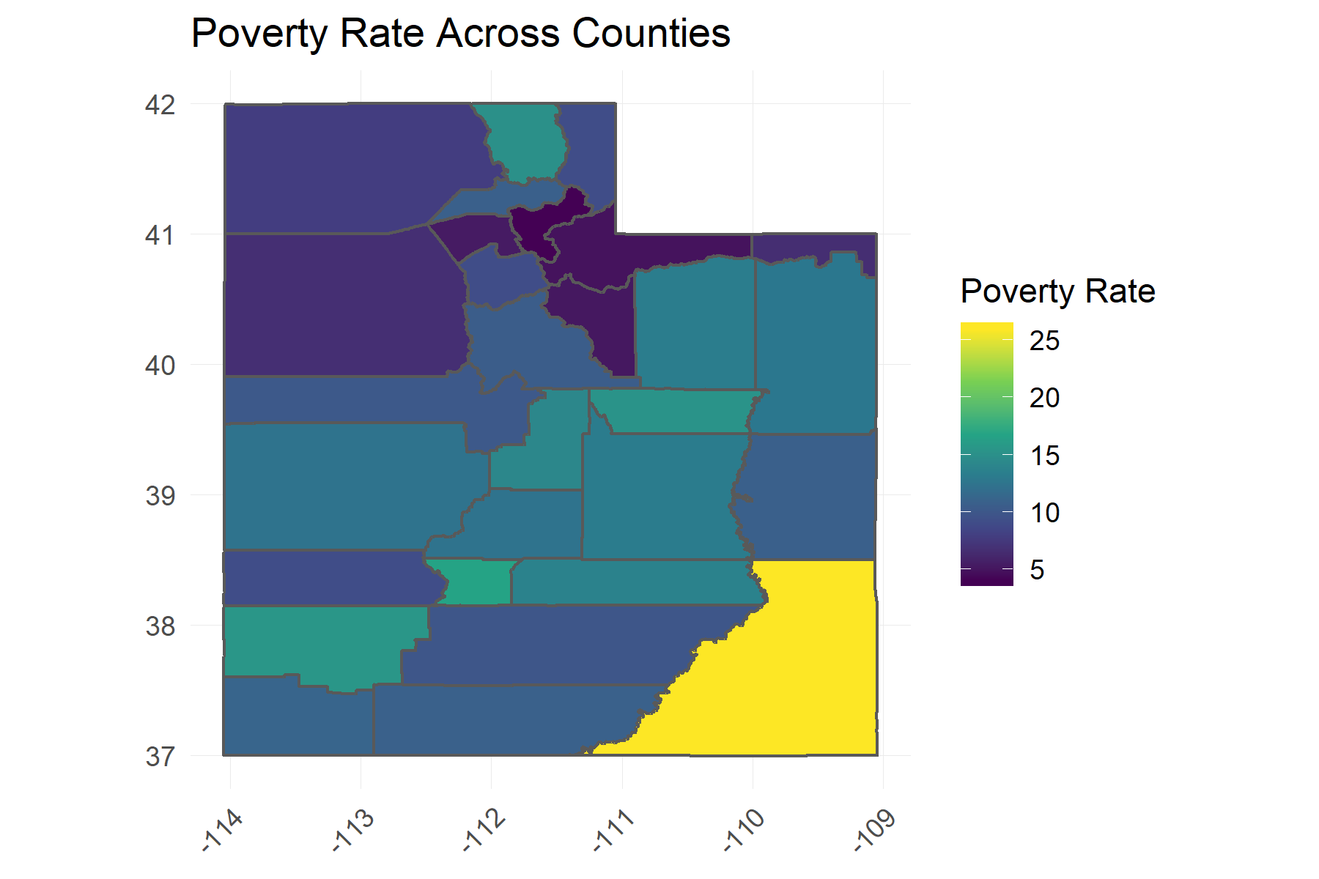

Central Utah Public Health has the most WIC Clinics in Utah , and Davis, Wasatch and Weber/Morgan Counties with the least number of WIC Clinics

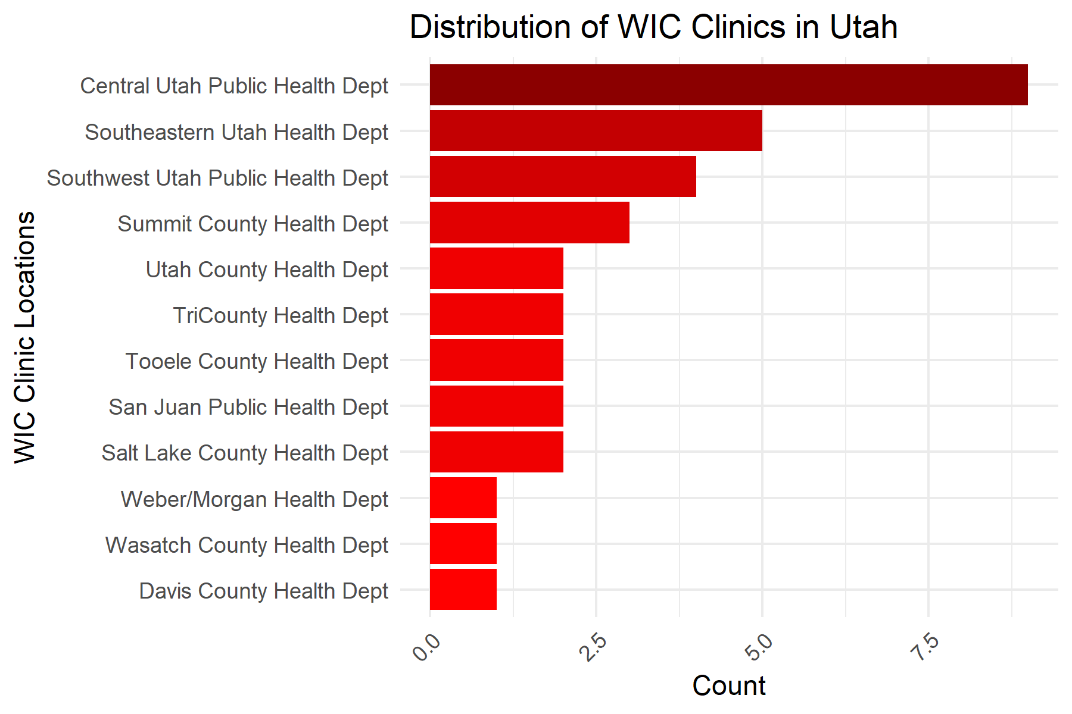

Salt Lake County has the most number of units under HUD programs. Tooele County has the least.

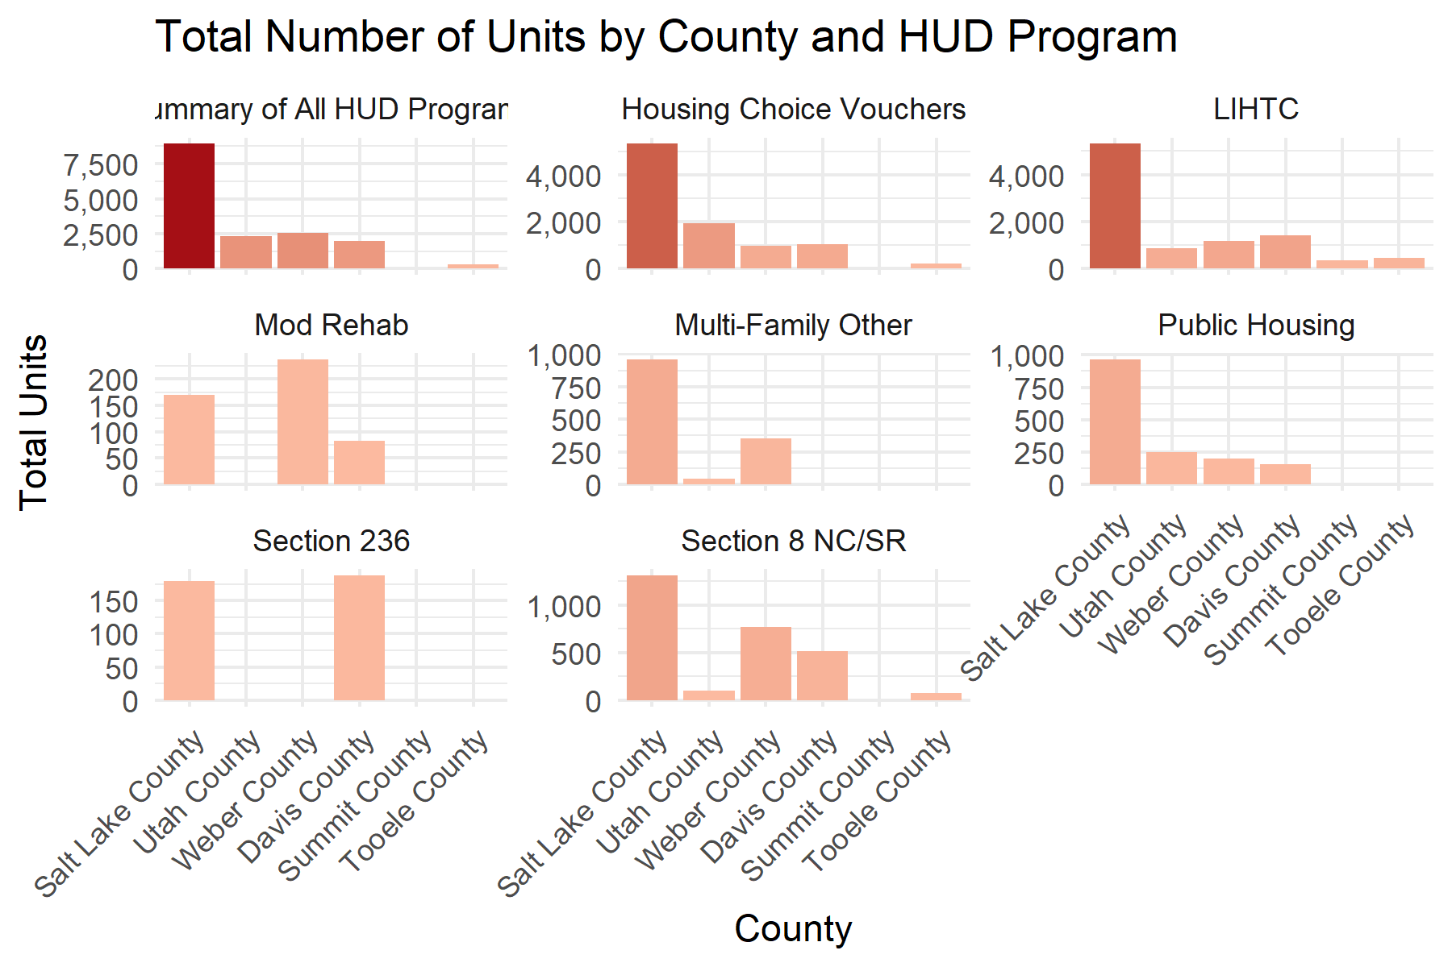

This plot shows the burden on HUD. Most programs show close to 100% occupancy.

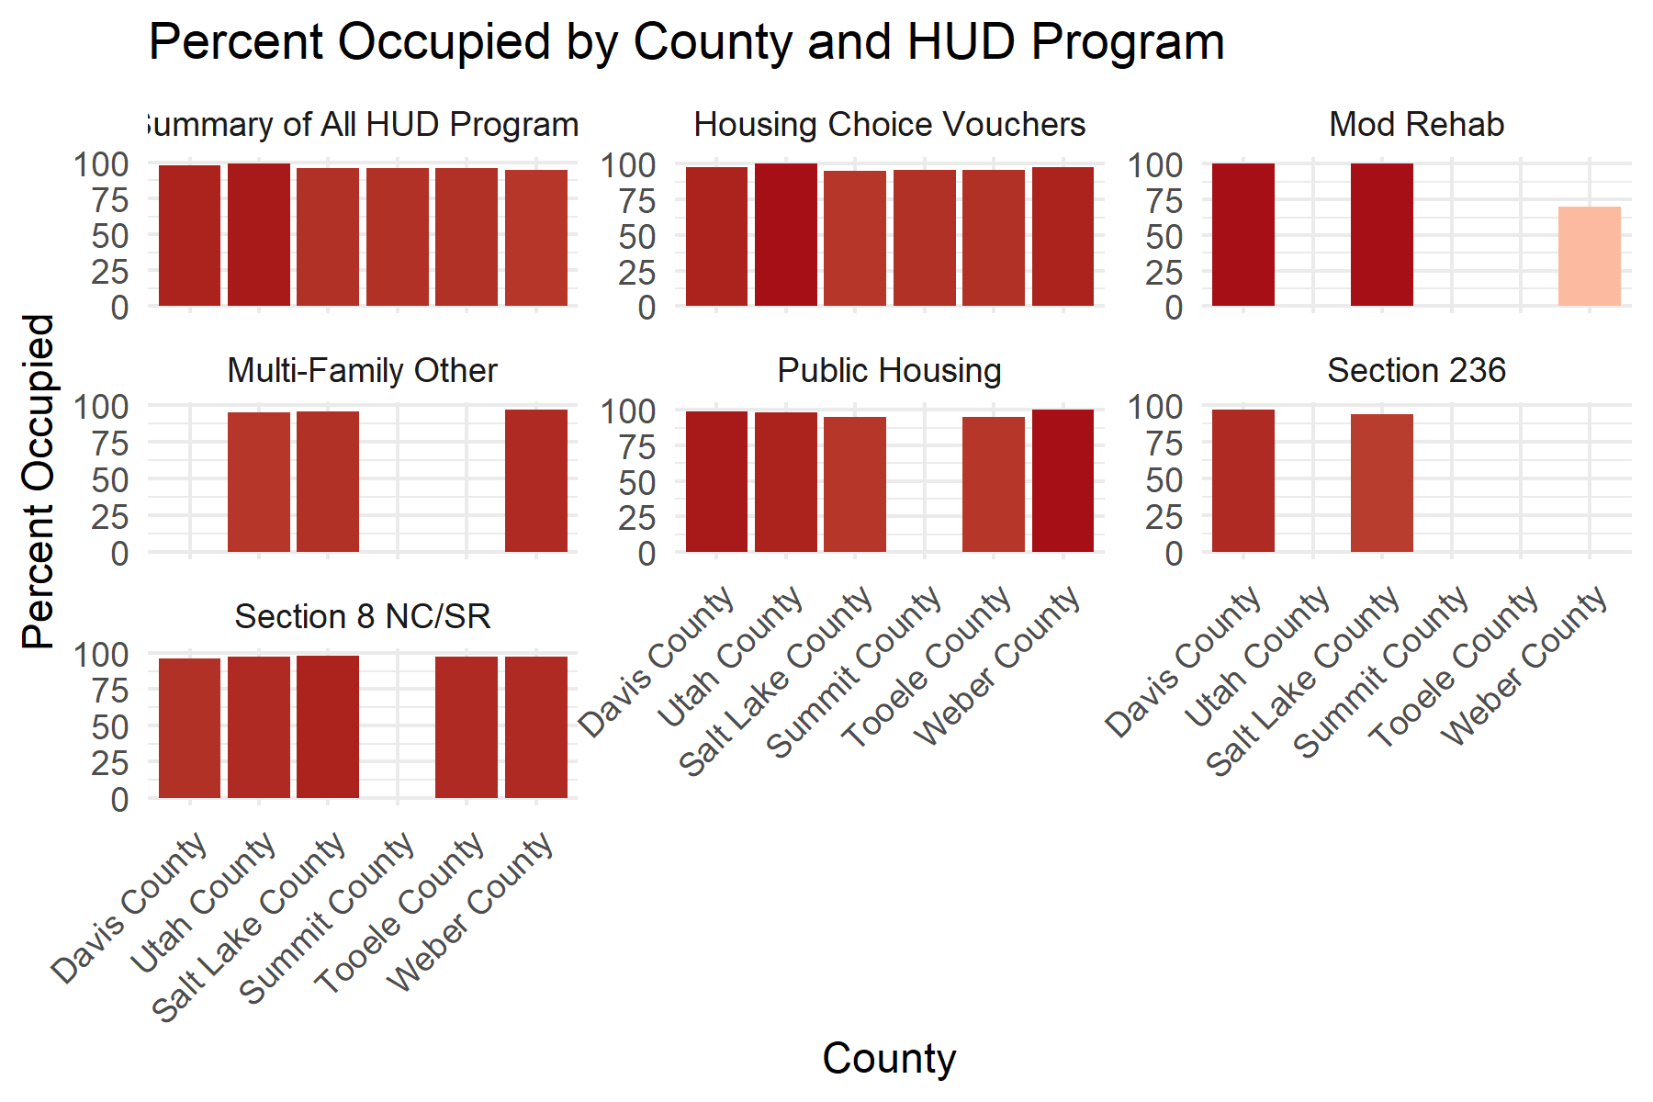

Most counties (except Summit) have a pretty long wait time, especially when it comes to Housing Choice Vouchers.

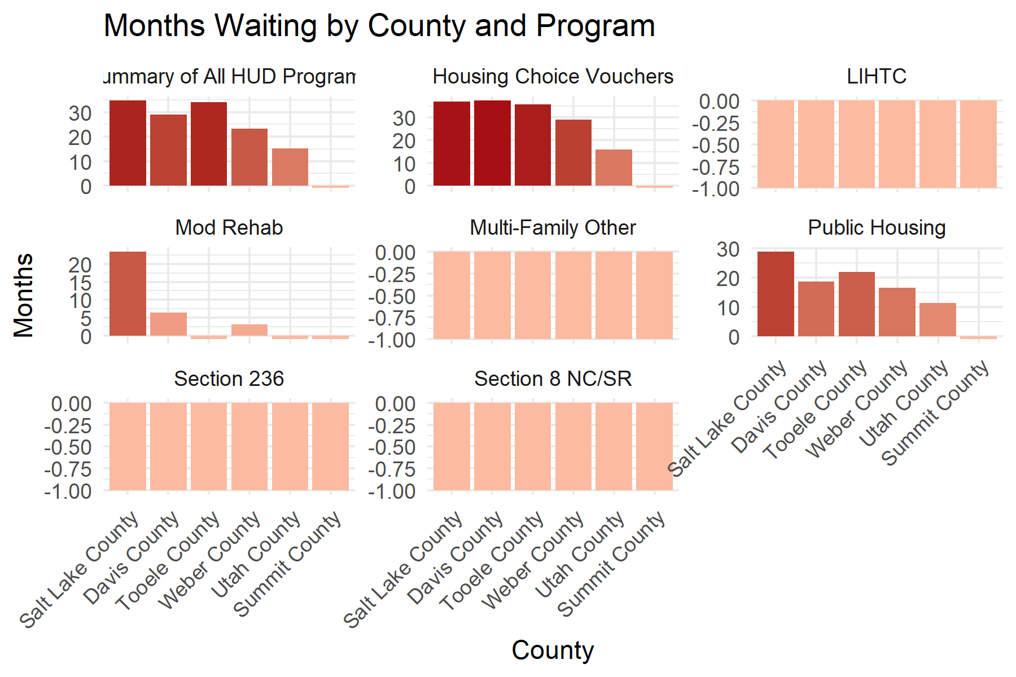

Summit County has the highest months from move in time, close to 15 months for housing choice vouchers.

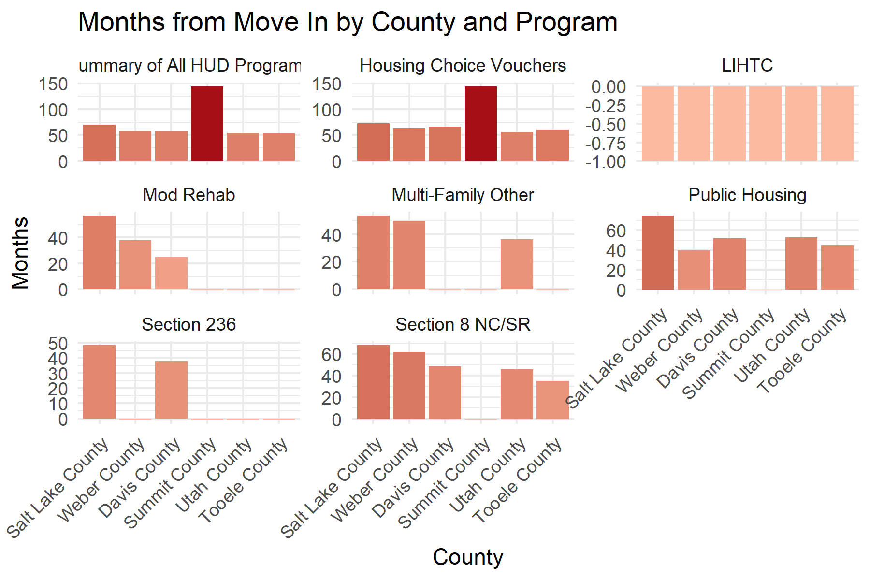

These plots show that Salt Lake City has the highest number of homeless headcounts by a very big margin.

